Day 12 – 25/6/2025
Barghavi Bethu
112728766 – bethubal

Task 1:
What is the binary 8 bit representation of A?
65/2 == 1
32/2 == 0
16/2 == 0
8 /2 == 0
4 /2 == 0
2 /2 == 0
1 /2 == 1
Binary representation 1000001
8 bit representation 01000001

Task 2:
What is the binary value of a?
Binary value of a
97/2 == 1
48/2 == 0
24/2 == 0
12/2 == 0
6 /2 == 0
3 /2 == 1
1 /2 == 1
Binary representation 1100001
8 bit representation 01100001

Task 3:
Types of Computer memory with examples.. Explain

1.Cache Memory: This is a small and high speed memory unit located close to CPU. It’s main purpose is to store frequently accessed data and instructions so the CPU can access them faster that fetching from main memory(RAM). Examples are cache memory in CPU, Web browser, mobile phones.
2.RAM: Random Access Memory is a type of volatile primary memory that temporarily stores data and instructions. It is one of the parts of the Main memory, also famously known as Read Write Memory. Random Access memory is present on the motherboard and the computer’s data is temporarily stored in RAM. As the name says, RAM can help in both Read and write.

3.D RAM (Dynamic RAM): D RAM uses capacitors and transistors and stores the data as a charge on the capacitors. They contain thousands of memory cells. It needs refreshing of charge on capacitor after a few milliseconds. This memory is slower than S RAM.

4.S RAM (Static RAM): S RAM uses transistors and the circuits of this memory are capable of retaining their state as long as the power is applied. This memory consists of the number of flip flops with each flip flop storing 1 bit. It has less access time and hence, it is faster.

5.ROM: ROM full form is Read Only Memory. ROM is a non volatile memory and it is used to store important information which is used to operate the system. We can only read the programs and data stored on it and can not modify of delete it.

6.MROM(Masked ROM): Hard-wired devices with a pre-programmed collection of data or instructions were the first ROMs. Masked ROMs are a type of low-cost ROM that works in this way.
7.PROM (Programmable Read Only Memory): This read-only memory is modifiable once by the user. The user purchases a blank PROM and uses a PROM program to put the required contents into the PROM. Its content can’t be erased once written.

8.EPROM (Erasable Programmable Read Only Memory): EPROM is an extension to PROM where you can erase the content of ROM by exposing it to Ultraviolet rays for nearly 40 minutes.

9.EEPROM (Electrically Erasable Programmable Read Only Memory): Here the written contents can be erased electrically. You can delete and reprogram EEPROM up to 10,000 times. Erasing and programming take very little time, i.e., nearly 4 -10ms(milliseconds). Any area in an EEPROM can be wiped and programmed selectively.

10.Virtual memory: A memory management technique where secondary memory can be used as if it were a part of the main memory. Virtual memory uses hardware and software to enable a computer to compensate for physical memory shortages by temporarily transferring data from RAM to disk storage.

Task 4:
What do you understand by data structures?
Data Structures is a way of organizing and storing data in an orderly manner so that it can be used efficiently. It is used to store data in a meaningful way, to access and modify data quickly, to solve problems efficiently using the right method.

Task 5:
What are the operations on data structures ?
Operations on data structures are the actions we perform to manage and manipulate data stored within them. These operations allow us to store, access, modify or remove data efficiently.
Some of the basic operations on data structures are Insertion, deletion. Traversal, searching, sorting, updating.

Task 6:
What are static and dynamic arrays key points summarize in a table?
Static Array | Dynamic Array
Size is fixed at the time of creation. | We can expand or shrink the size of array during runtime. This can be done manually or automatically
Memory allocation is done at compile - time | Memory is allocated during runtime(heap memory)
Less flexible | More flexible
Slightly faster | Slightly slower mainly due to resizing logic
More manual work is needed | Easier with built in methods.
Memory is waster due to overestimate of size | Lesser chances for memory wastage as we can adjust size.
C, C++ | Python(list), java(Arraylist),C  ++

Task 7:
Reverse an array. write a code.
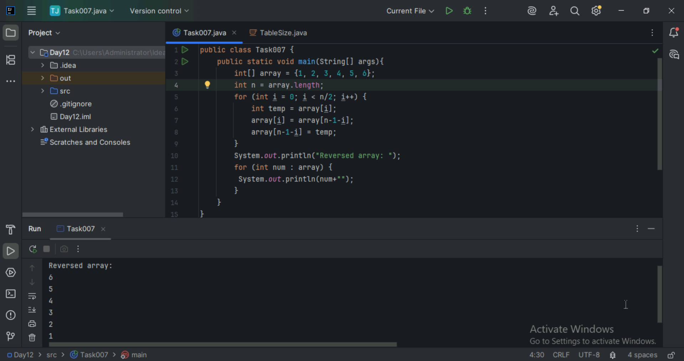

Task 8:
Reverse a string .. write a code.
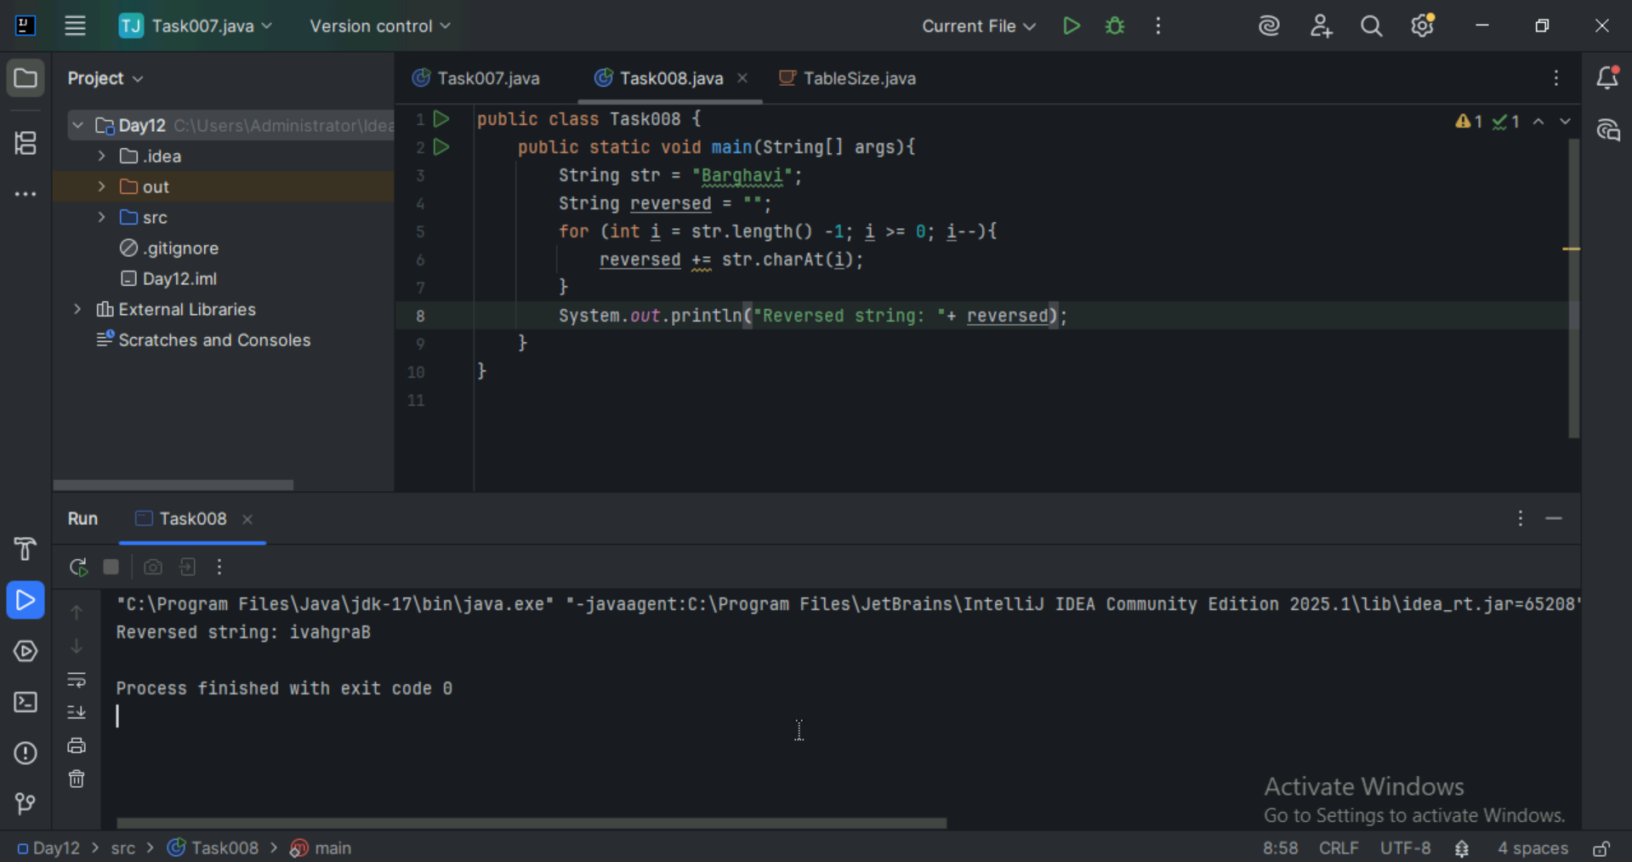

Task 9:
Leetcode and Hackerrank … accounts ..

Task 10:
public class Example {
public static void main (String[] args) {
int[] arr1 = {11, 34, 66, 75};
int n1 = arr1.length;
int[] arr2 = {1, 5, 19, 50, 89, 100};
int n2 = arr2.length;
int[] merge = new int[n1 + n2];
int i = 0, j = 0, k = 0, x;
System.out.print("Array 1: ");
for (x = 0; x < n1; x++)
System.out.print(arr1[x] + " ");
System.out.print("\nArray 2: ");
for (x = 0; x < n2; x++)
System.out.print(arr2[x] + " ");
while (i < n1 && j < n2) {
if (arr1[i] < arr2[j])
merge[k++] = arr1[i++];
else
merge[k++] = arr2[j++];
}
while (i < n1)
merge[k++] = arr1[i++];
while (j < n2)
merge[k++] = arr2[j++];
System.out.print("\nArray after merging: ");
for (x = 0; x < n1 + n2; x++)
System.out.print(merge[x] + " ");
}
}

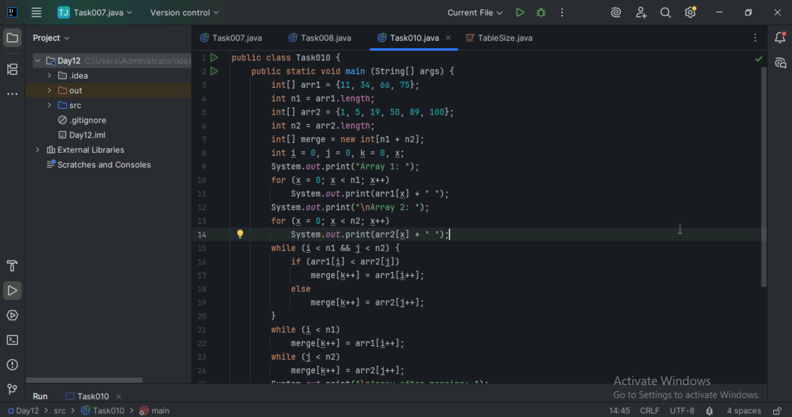
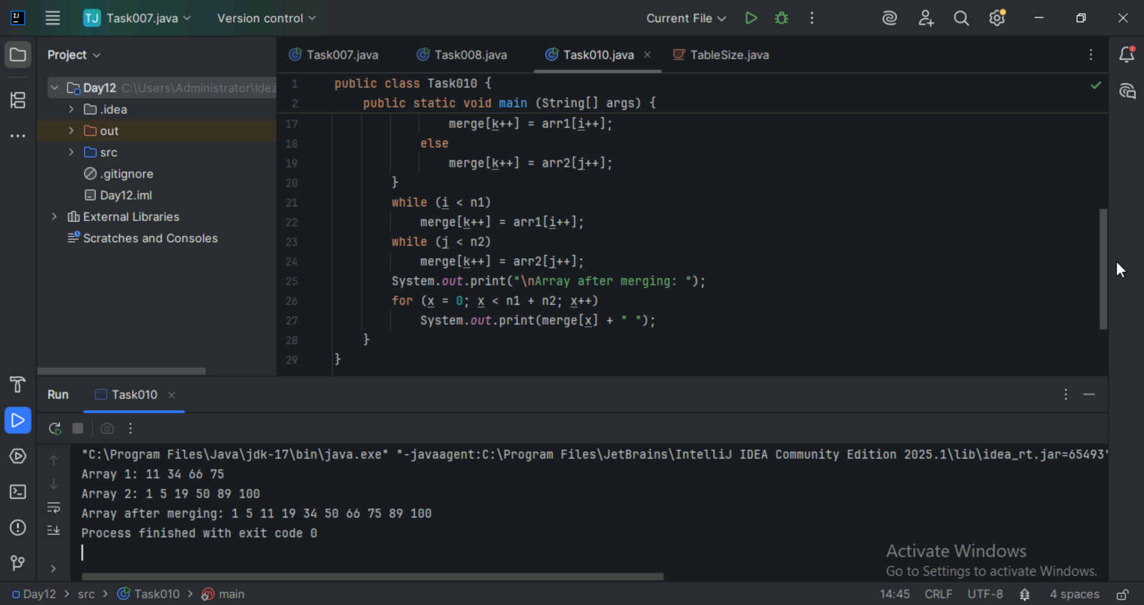

What is the above code snippet doing..?

Task 11:
What do you know about hash table?
A hash table is a data structure that stores data in key-value pairs and uses a hash function to map each key to a specific location (called an index or bucket) in memory for fast access. In simple terms hash table is like a dictionary, if we look up a word(key) it gives the meaning(value) instantly.

Task 12:
Wap to create a hash table and display them..

Hint 👍

Import java.util.Hashtable;
Import java.util.Map;

import java.util.Hashtable;
import java.util.Map;

public class Task012_DS_HashTable {
public static void main(String[] args) {
Hashtable<String, Integer> ht = new Hashtable<>();
ht.put("Anitha", 101);
ht.put("Kavitha", 102);
ht.put("Meera", 103);

for (Map.Entry<String, Integer> e : ht.entrySet())
System.out.println(e.getKey() + " " + e.getValue());
}
}

// Map is an interface

// hash table --> slower , sync , thread safe, no null value accepted

// hash map --> faster while retrieving, asynchro , only one null key and multiple null values..

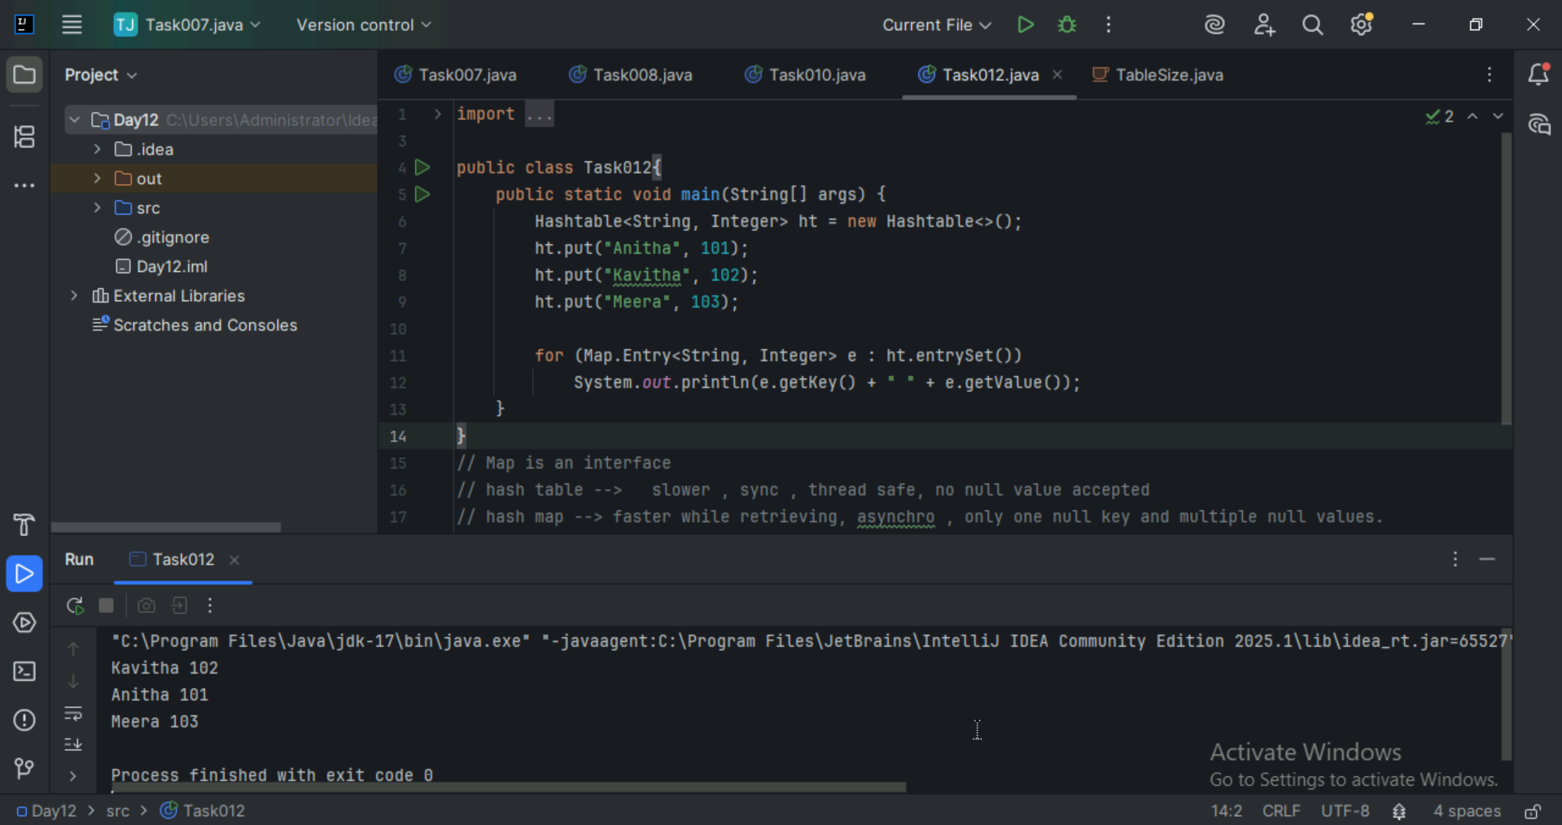

Task 13:
Wap to create a hash map and display them..

import java.io.*;
import java.util.*;

class Task013_DS_HashMap {

public static void main(String args[]) {
HashMap<Integer, String> hmobj1 = new HashMap<>();

HashMap<Integer, String> hmobj2 = new HashMap<Integer, String>();

hmobj1.put(10, "Anitha");
hmobj1.put(20, "Saritha");
hmobj1.put(30, "Ankitha");

hmobj2.put(44, "John");
hmobj2.put(55, "Steve");
hmobj2.put(66, "Jack");

System.out.println("Mapping HashMap hmobj1: " + hmobj1);

System.out.println("Mapping HashMap hmobj2: " + hmobj2);
}
}

//set -- arrayList , replace the values , updates the previous value
//put -- hash table , insert the value, puts a new value

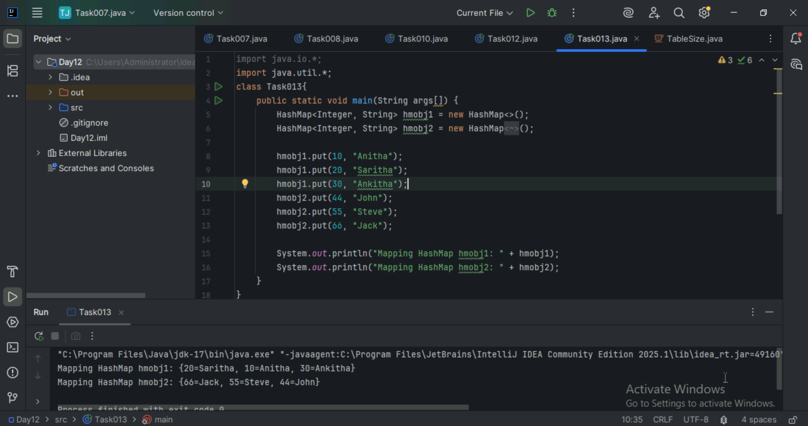

Task 14:
Hash table advantages and disadvantages?

Advantages of Hash Tables
1. Fast Lookup, Insertion, and Deletion (O(1) Average Case)
2. Efficient for Large Datasets
3. Flexible Key Types
4. No Need for Ordered Data
5. Widely Supported
Disadvantages of Hash Tables
1. Collisions
2. No Order
3. Memory Overhead
4. Complex Implementation Details
5. Not Suitable for Range Queries

Task 15
Linear probing in Hash table

public class HashTable<Key, Value> {
private class HashTableNode {
private Key key;
private Value value;
private boolean active;
private boolean tombstoned; // Allow reuse of removed slots
public HashTableNode() {
// All nodes in array will begin initialized this way
key = null;
value = null;
active = false;
tombstoned = false;
}
public HashTableNode(Key initKey, Value initData) {
key = initKey;
value = initData;
active = true;
tombstoned = false;
}
}

private final static int TABLE_SIZE = 9;
private Object[] table;
public HashTable() {
// Since HashNodeTable has generics, we can not have
// a new HashNodeTable[], so use Object[]
table = new Object[TABLE_SIZE];
for (int j = 0; j < TABLE_SIZE; j++)
table[j] = new HashTableNode();
}
public Value put(Key key, Value value) // TBA

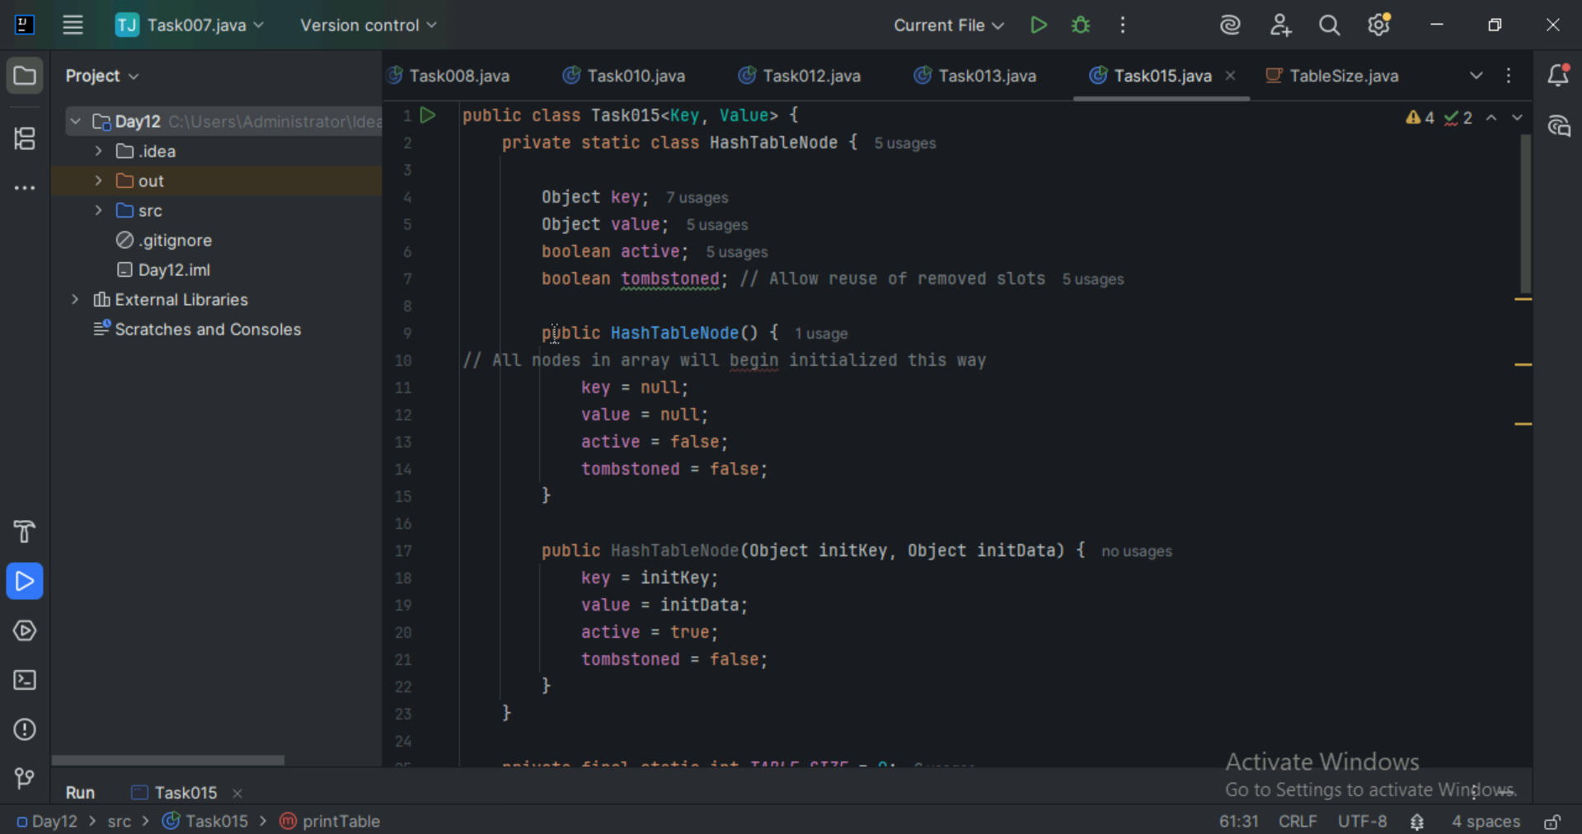

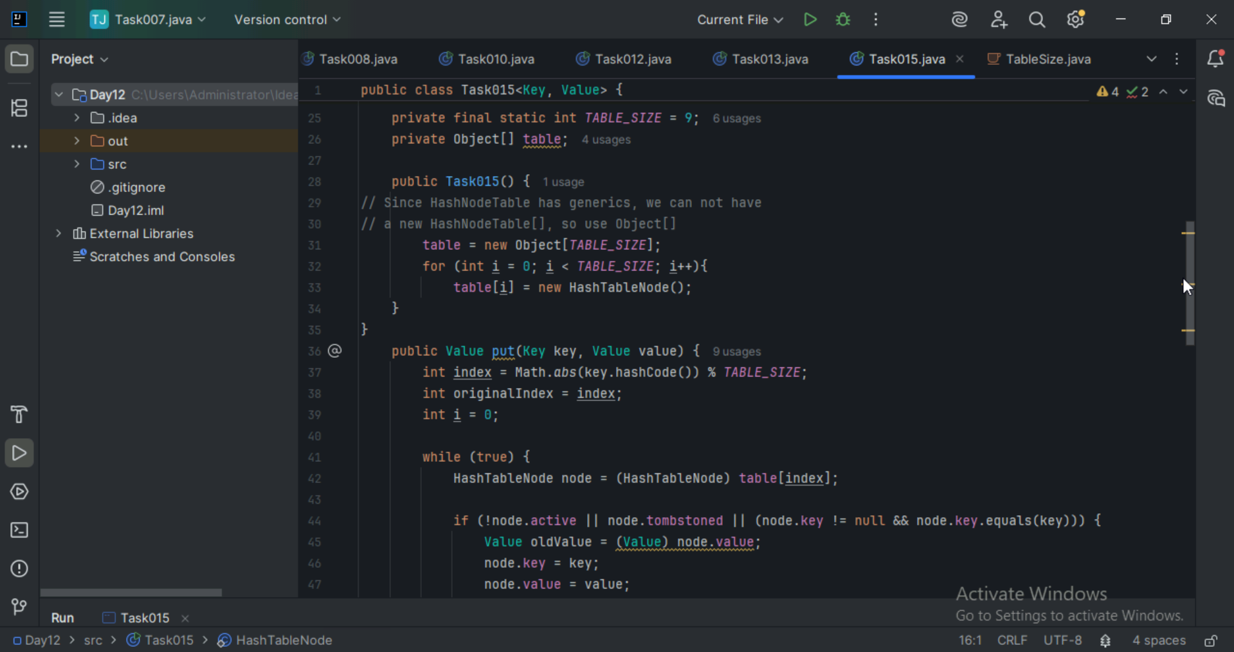
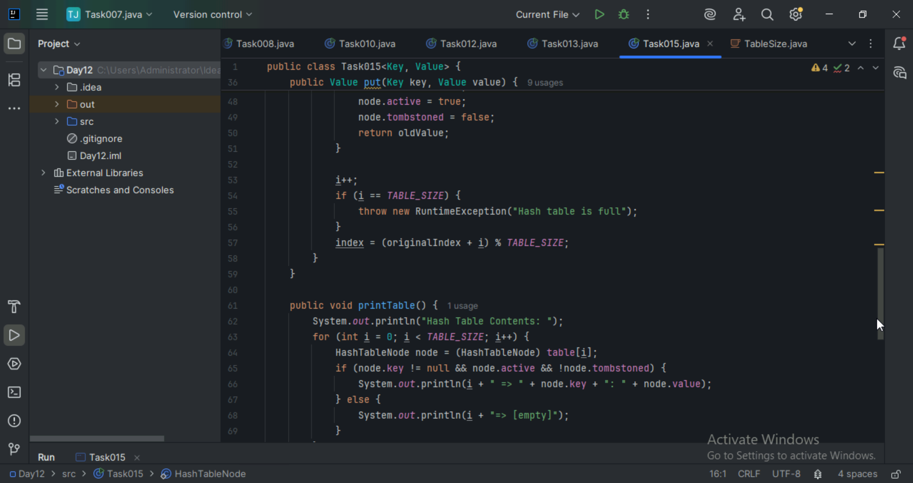

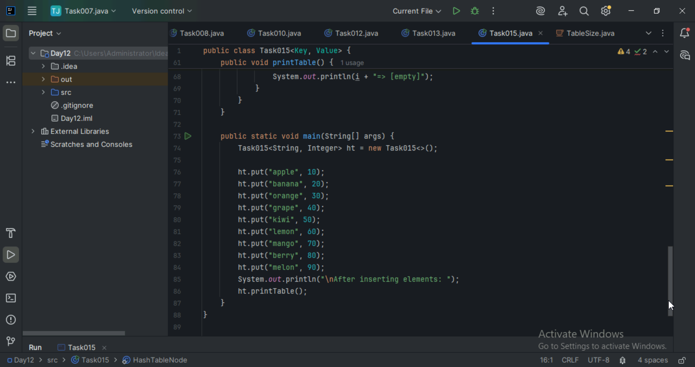
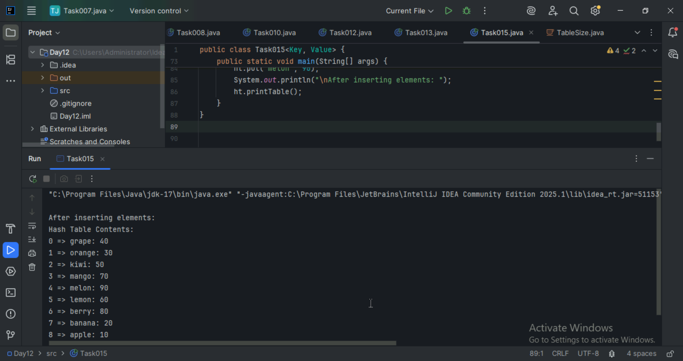

Task 16:
Methods of Hash table plz list them.

- put(K key, V value): Inserts a key-value mapping into the Hashtable. If the key already exists, the old value is replaced with the new one.

- get(Object key): Returns the value associated with the specified key. Returns null if the key is not found.

- remove(Object key): Removes the key-value mapping for the specified key from the Hashtable.

- containsKey(Object key): Returns true if the Hashtable contains a mapping for the specified key, otherwise returns false.

- containsValue(Object value): Returns true if the Hashtable maps one or more keys to the specified value, otherwise returns false.

- isEmpty(): Returns true if the Hashtable contains no key-value mappings, otherwise returns false.

- size(): Returns the number of key-value mappings in the Hashtable.

- clear(): Removes all key-value mappings from the Hashtable.

- keySet(): Returns a Set view of the keys contained in the Hashtable.

- values(): Returns a Collection view of the values contained in the Hashtable.

- entrySet(): Returns a Set view of the key-value mappings contained in the Hashtable.

- rehash(): Increases the size of the Hashtable and rehashes all of its keys. This method is protected and typically handled internally by the Hashtable for performance optimization.
- clone(): Returns a shallow copy of the Hashtable instance.

Task 17:
In Task 13 of hash Map .. we were using string and integer / integer and string
Like HashMap<Integer, String>

Can you change to String and string and c if it works
Like this HashMap<String, String> ? will this work?
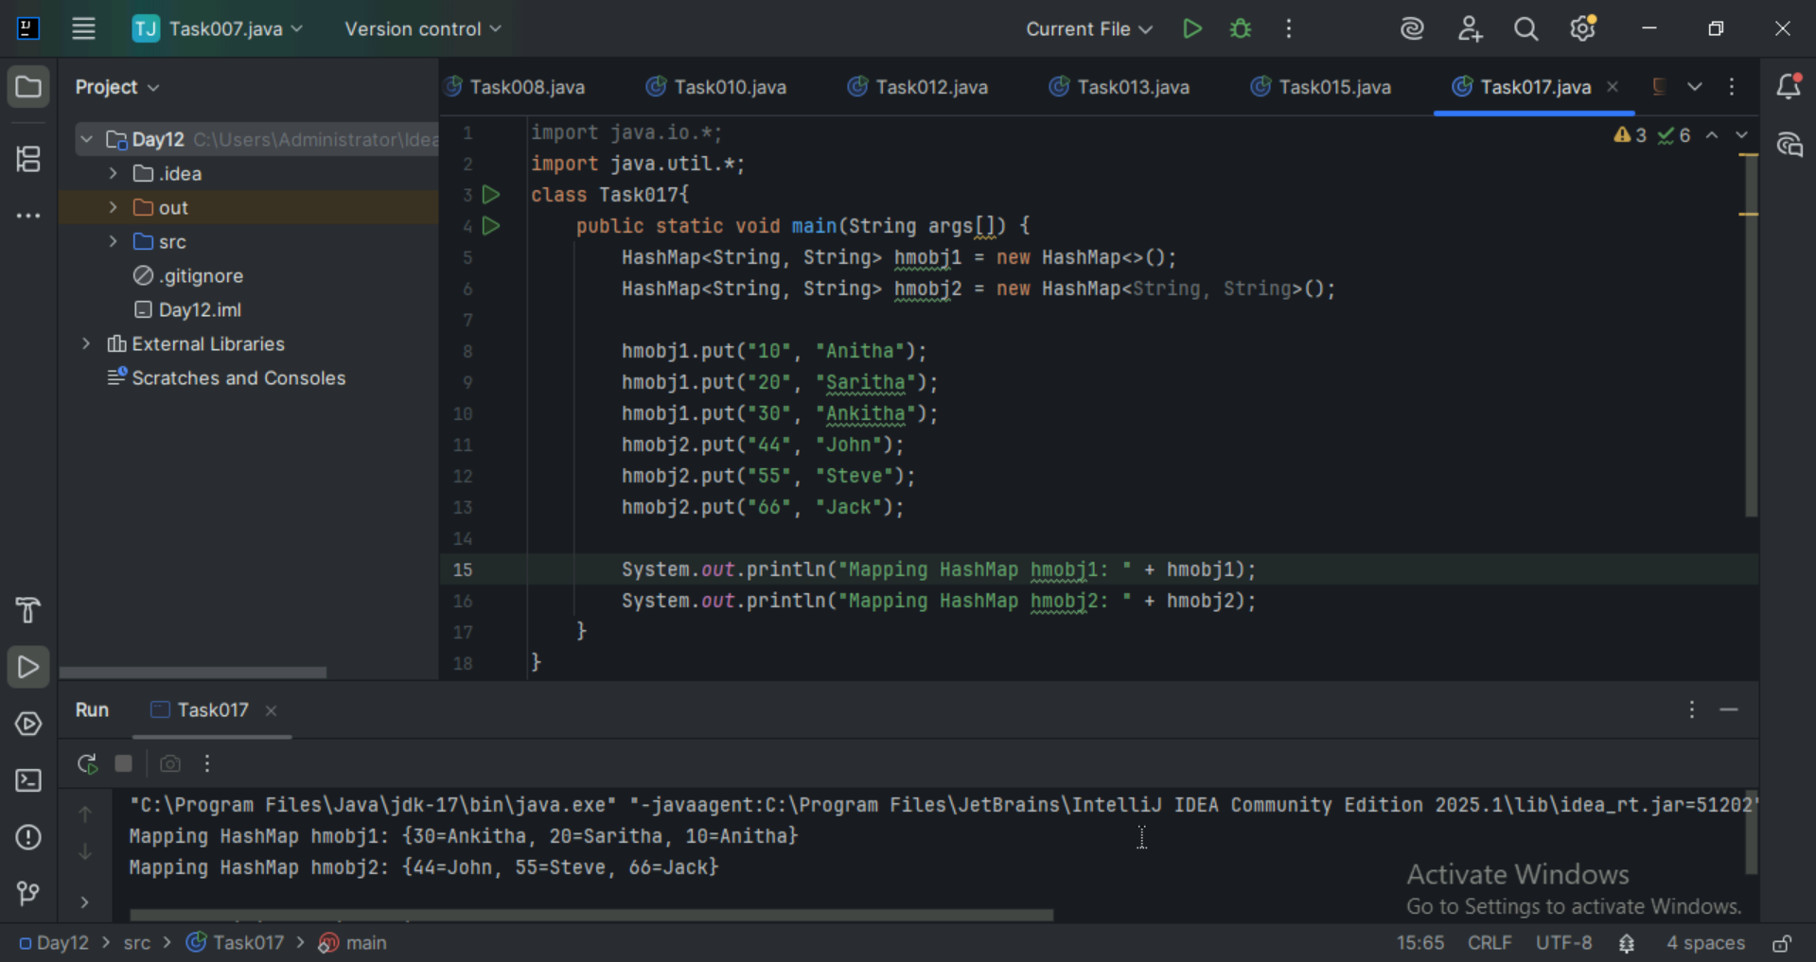

Task 18:

Explain the internal working of a HashMap. With diagram?
- Hashing

Every key is passed through a hash function to generate a number called as hash code.

This is converted to an index in the array using index = hashCode % array Size
- Inserting a Pair(put)

This calculated the index using the hash of the key. Places the key value in that index. If there is any other key already inserted in that index collision occurs, then a linked list is formed.
- Retrieving a value

This hashes the key and finds the index. Searches the index to find the key.

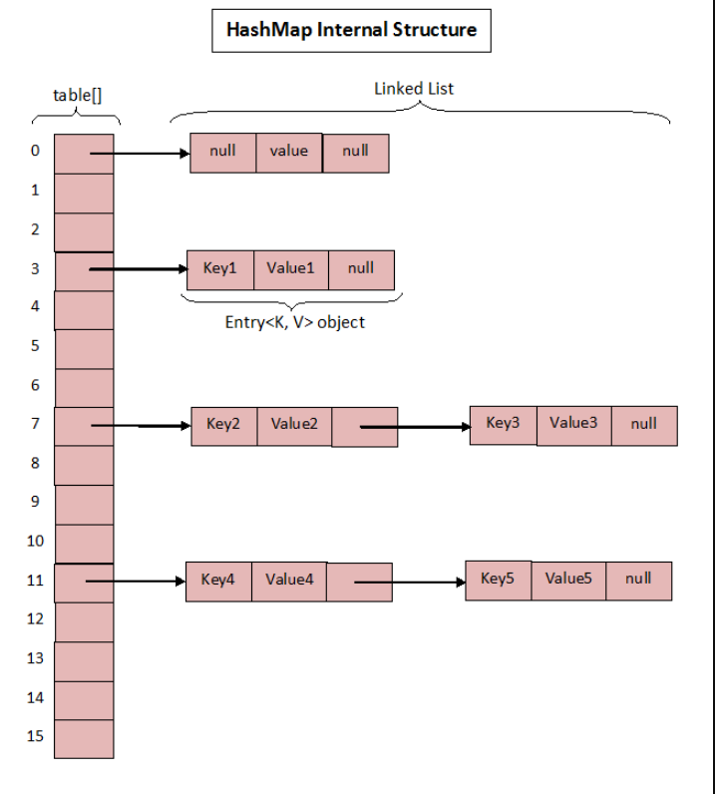

Task 19:
Try to add 1 null value in the key and run the hash map code..

Also add one more null value to the key and see the result..

Sample 👍

import java.util.*;
import java.io.*;
public class Task019_Ds_HashMapNull {
public static void main(String[] args) {
HashMap hmap=new HashMap();
hmap.put(101,"Prasunamba");
hmap.put(null,"Meher");
hmap.put(null,".MK");
System.out.println(hmap);
}
}
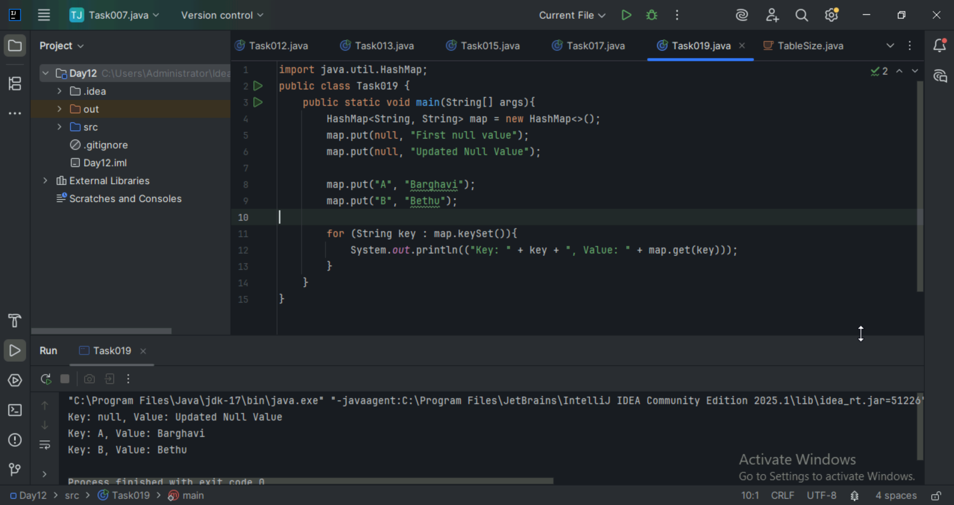

Task 20:
How many methods are there to create a hash Map?
1. Using default constructor - Created an empty HashMap with default initial capacity and load factor.
HashMap<String, String> map = new HashMap<>();
2. Using Initial Capacity – Sets the initial capacity to 50 and also it is more useful when we have the data of number of entries.
HashMap<String, String> map = new HashMap<>(50);
3. Using initial capacity and load factor – We can control both how much memory is allocated and when it resizes.
HashMap<String, String> map = new HashMap<>(50, 0.9f);
4. Using another Map – Created a new HashMap with the same key value pairs as original.
Map<String, String> original = new HashMap<>();
Original.put(“A”, “Apple”);
HashMap<String, String> copy = new HashMap<>(original);

Task 21:
Wap to make a Hashmap synchronized..

Plz note : Hash Map are - asynchronous in nature..

import java.util.Collections;
import java.util.HashMap;
import java.util.Map;

public class task021_DS_HashMap_SyncMap {
public static void main(String[] args) {
HashMap<String, Integer> Hm1 = new HashMap<String, Integer>();
Map<String, Integer> syncMap = Collections.synchronizedMap(Hm1);
}
}
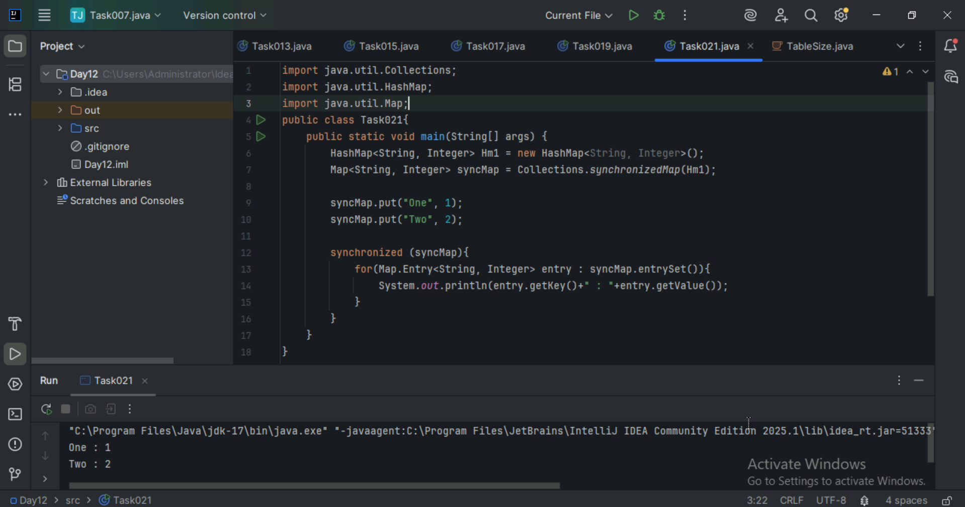

Home Tasks:

Do hash table have linked list internally?

Yes, many implementations of hash tables use linked lists internally — especially for handling collisions. This technique is known as separate chaining.

Do collisions occur in hash Maps? What are they?

Yes, collision do occur in HashMaps and they are a fundamental part of how HashMaps works internally. All collisions happen due to multiple keys mpping to the same index in the internal array.

What is load factor and how the capacity increases?

The load factor is a measure of how full the HashMap is allowed to get before it resizes (i.e., increases its capacity). If the load factor exceeds a predefined threshold, the HashMap automatically resizes (i.e., grows in capacity). The default load factor in Java is 0.75.

Load Factor = Number of Entries / Capacity (Bucket Size)

Too low → Less collisions, but wastes memory

Too high → Saves memory, but more collisions, degrading performance

How Capacity Increases in HashMap

1. Initial Capacity: Default is 16 (if not specified).
2. Load Factor Threshold: Default is 0.75.
3. Resize Trigger: Resize happens when number of entries > (capacity × load factor)
4. Resize Process: Capacity is doubled.

All existing entries are rehashed to new buckets. It's a costly operation, so it's done carefully

